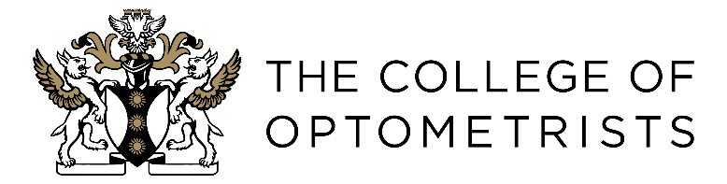

Memorandum of Understanding between The College of Optometrists

and

College representatives on external committees and working groups

- This Memorandum of Understanding (MoU) sets out an agreed arrangement between The College of Optometrists (“The College”) and its representatives (“the Representative”) on external committees and working groups (“committees”), outlines our shared purpose, and agreed values and principles for engagement.

Shared vision and purpose
- Our shared vision is to ensure optometrists are at the forefront of better eye health and vision for all.

- Our shared purpose is to inspire and support optometrists to excel in the provision of eye health care, always for the benefit of patients.

- The Representative will support The College by providing expert advice as requested to external committees with the aim of:
- Representing the College and its positions and guidance
- Effectively amplifying the expert voice of optometrists
- Defining and supporting good clinical practice
- Promoting lifelong learning and career advancement

Joint working
- The College and the Representative agree to:
- Work together openly, transparently and constructively
- Promote high quality accessible eye care and the role of optometrists
- Support sharing of good practice

- The College will support the Representative to provide up-to-date and evidence-based clinical and professional opinion and advice to external committees.

- The College and the Representative recognise that where opinions may differ, differences will be handled with integrity on both sides and without impeding joint work and the committee’s progress.

- In particular, The College will:
- Provide expert, timely, evidence-based recommendations and advice to the Representative on relevant policy and clinical areas
- Support Representatives in effectively contributing to the work of the committee

- The Representative will:
- Support the work of the College and represent its relevant positions and guidance
- Engage with the College, as needed, to seek the College’s views to inform the work or decisions of the committee.
- Consult the College before endorsing or approving on behalf of the College any document produced by the committee
- Keep the College updated about the activities and decisions of the committee.

- Both parties will adhere to the College values:
- We act with integrity and transparency
- We listen and we learn
- We demonstrate respect and professionalism
- We achieve high quality
- We champion equality, diversity and inclusion.

Contact details
- Details of contacts of The College and the Representative are contained in appendix A.

Terms of Reference
- The Terms of Reference sets out the roles and responsibilities of the College and the Representatives to ensure consistent communication. The Terms of Reference has been shared together with this Memorandum of Understanding.

Liability
- This MoU is not legally binding and shall not give rise to any rights including intellectual property rights or liabilities for any party.

- Nothing in this MoU is intended to, or shall be deemed to, establish any partnership or joint venture between the parties, constitute either party as the agent of the other party, nor authorise either of the parties to make or enter into any commitments for or on behalf of the other party.

Duration and review
- This MoU takes effect from the date of signing and will remain in force until the Representative has completed their role on the committee, or the MoU is terminated by mutual agreement, or superseded by a revised document.

- This MoU will be reviewed every two years, unless business needs require earlier review. Each review will:
- Report on actions arising from the implementation of this MoU in the preceding two years
- Review the effectiveness of this MoU in achieving its aims and make amendments where necessary
- Identify areas for future collaboration
- Ensure the contact information for each organisation is accurate and up to date.

Signature
Signed for and on behalf of the Representative | Signed for and on behalf of The College
Signed | Signed 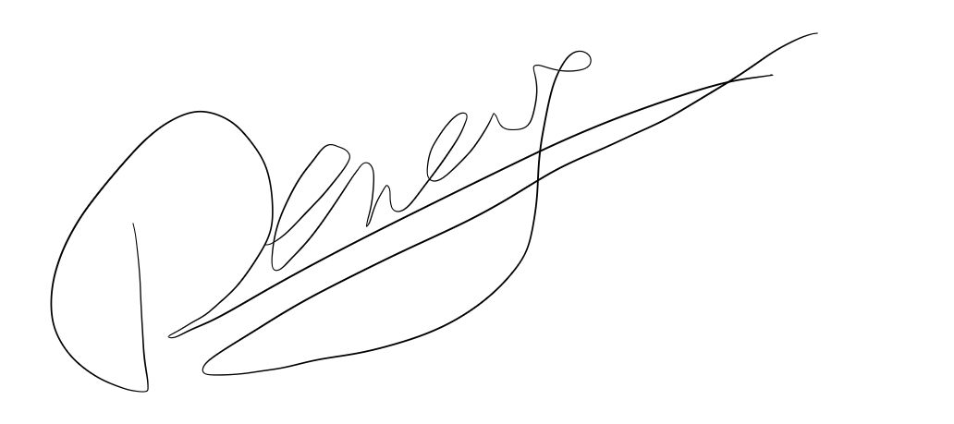
Name: | Name: Olivier Deneve
Title: | Title: Mr
Date: | Date: 19th December 2022

Appendix A
Contact details

- The College of Optometrists

Name: Caroline Meares

Email: policy@college-optometrists.org

- The Representative

Name:

Email:

